For youth grades 9-12!
Spring 2020
Synod Youth Gathering—March 6-8th Camp Arnold Eatonville. For youth grades 8 & 9th. Cost: $70.00 per person (this is ½ the actual price). Registration and payment due Feb. 9.
May Holden Youth Weekends! Youth grades 9-12. May 15-17 (Friday - Sunday). We will leave Thursday, May 14 to drive over to Wenatchee.
Theme: “Transformation” Theme Verse: 1 John 3:2 “Beloved, we are God’s children now; what we will be has not yet been revealed.” Change is constant and transformation is sacred. How can we express our changing hearts and minds to speak out as change makers in God’s World?
Cost: $155.00 per person (actual cost is $205.00pp). Registration form and $100.00 non-refundable deposit due January 26. final payment due Feb. 16.
Summer 2020
Mexico Mission/Service Trip—June 26-July 4 for youth grades 9 + and adults (Intergenerational Trip). Youth must bring an adult/parent with them or be sponsored by another adult attending the trip. More info coming Winter 2020.
Summer Camp for students going into grades 4-9th in the fall of 2020. July 11-18(including travel dates). Flathead Lutheran Bible Camp MT—see youth board for more info and how to register.
High School Immersion/Service Trip August 13-18 (Thursday to Tuesday) -- Spaces are limited to 10-12 youth. During our trip we will walk and serve alongside Native Americans who live along the Columbia River as well as community members from Shepherd of the Hills Lutheran Church in Stevenson WA. Cost: $125.00 per person. Registration and $50.00 deposit due Feb. 23. This trip will consist of a mixture of service work and cultural immersion.

*All 2020 registration forms and detailed information will be available on the youth board by December 15, 2019.

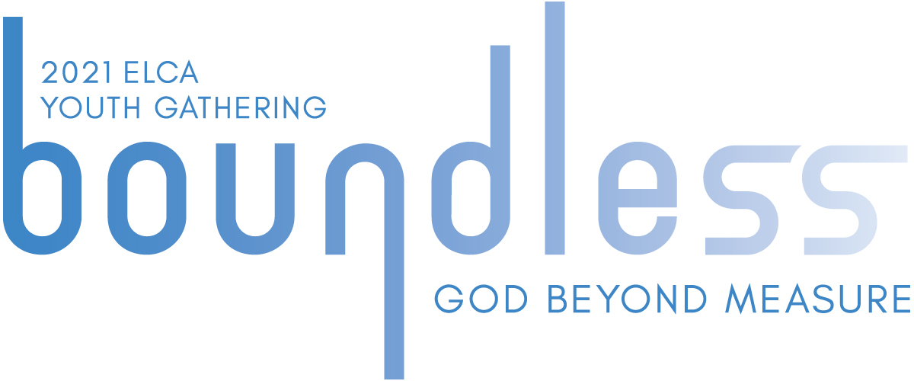

ELCA Youth Gathering 2021! Minneapolis MN June 29-July 3 (travel dates June 28 and early July 4). Theme: boundless: God beyond measure Ephesians 3:19 for youth grades 9-12 (fall 2020).
Est. Costs per person: $1250.00

Breakdown: Registration Fee: $350.00 –firm unless you register after Nov. 1.
Housing: $350-$400.00; Meals: $250.00-$300.00; Extra activities: $50.00; Travel: $300-$400.00
I will be registering our group Oct. 6. Non-refundable $150.00 deposit due and registration materials due by Oct. 4. How to register available later this summer, early September.

