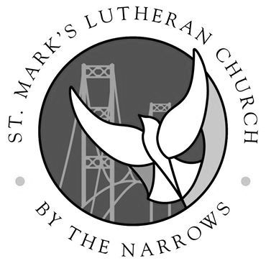
St. Mark’s Lutheran Church
Scholarship Committee
6730 N 17th St, Tacoma WA
TACOMA, WA 98406

Scholarship Application for Continuing Students:
2020-2021 School Year

Personal Information
Name: |  | Cell Phone:
Date of Birth: |  | Email Address:
Mailing Address:

Which institution of higher education do you plan to attend for the 20-21
school year?
Please provide your student ID Number:
List the mailing address of the Financial Aid Office at this institution:
Street:
City, State, & Zip:

Educational Information
Anticipated Graduation Date:
Cumulative GPA:

Please list all previous colleges or universities attended:
Name of Institution | Dates Attended

Additional Application Requirements
- Attach a digital photograph of yourself with your application.
- Write a brief essay (1-2 pages) where you:
  - Introduce yourself
  - Describe your goals & aspirations.
  - Reflect on your past year of education (e.g., What were some of the highlights and challenges? What did you learn?).
  - Describe your relationship with St. Mark’s at this time in your life
  - Include any of the following information that would allow the committee to gain a more complete picture of you: your leadership, volunteer opportunities, clubs, employment, athletics, and extra-curricular school activities.
- Include two letters of recommendation (as pdf files) with your application to scholarships@smlutheran.org.
  - The letters should describe your character and leadership abilities along with any other pertinent information that can be given. The letter should be no more than one page in length (see “Letters of Recommendation” template provided on the website).

Deadline
All materials must be submitted in PDF format (excluding the photograph) by Sunday, April 26th

